Some of the extra results you can get for the "ten" building are:
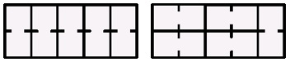

There are also ones like;
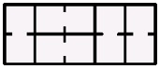

if the pupils are allowing reflections. Here is a table of results for buildings that are only 2 wide.

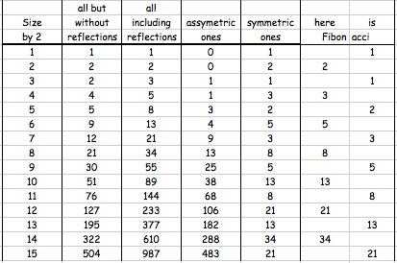

Seeing Fibonacci sliding into the Symmetric Ones pattern as well as the ALL results, may lead to exploring that pattern too!

Then you can explore rooms being allowed that are three times the size of the single rooms.

What happens if there is an upstairs that has similar rooms.

ETC. ETC. ETC.

