
Here is Gemma and Flo’s work:
Forgot the Numbers

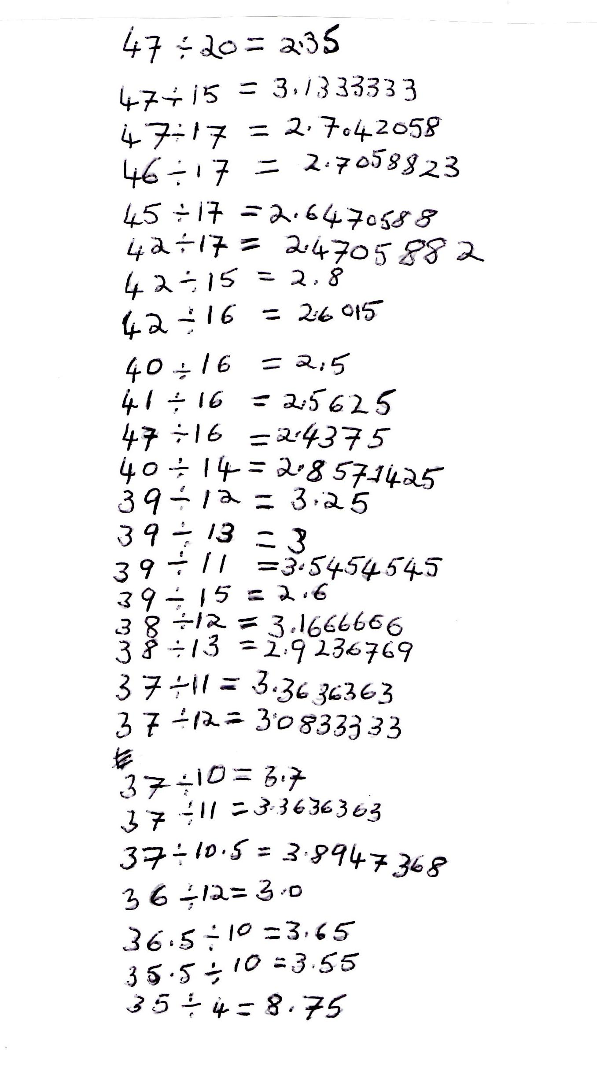

Richard wrote the following:

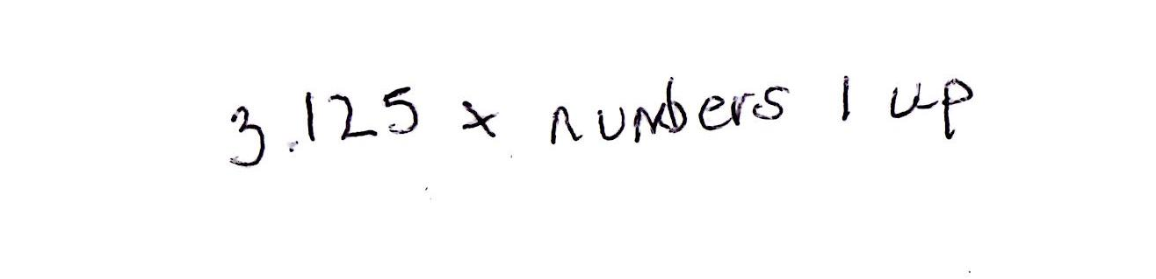

He explained:
“ I multiplied 3.125 by 1, then I tried multiplying 3.125 by 2, then I multiplied 3.125 by 3 … “

Here is the start of Thomas’ work:
“ I first looked at the number 0.125 and worked out what fraction of 1 it is. It turned out that it was an eighth.”

Can you take each of these starting ideas and develop it into a solution?

