Lyneham Primary Year 5/6 Math Challenge Group
Each group used a complete set of paper dominoes to learn about the system of numbers on the dominoes (barely any students had played dominoes, except for making a trail of dominoes fall down). It didn’t take them long to lay it out as on the photo below.

Individual group solutions on the next couple of pages.
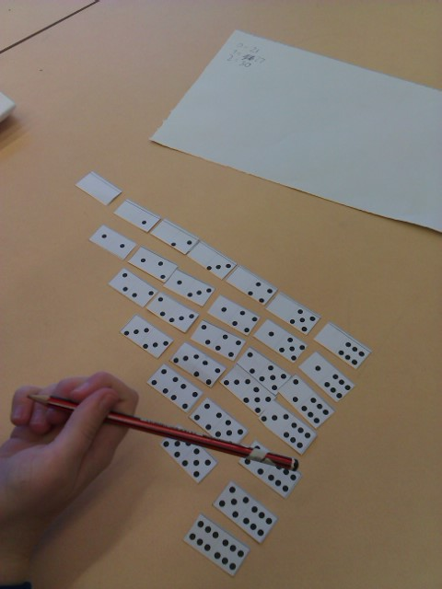

Jay-Jay, Sally, Jeffrey
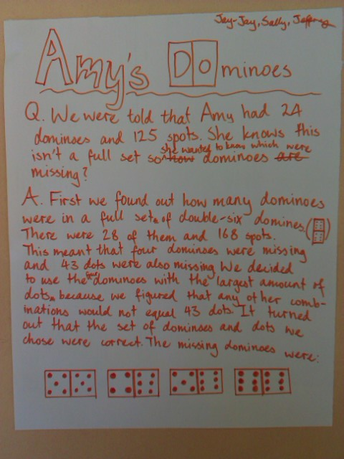

Freya and Brendan
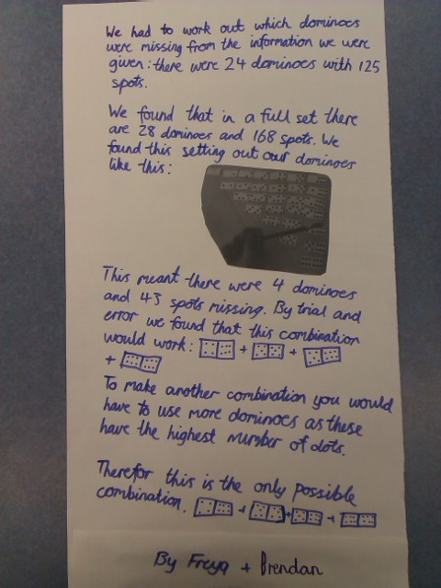

Morgan and Jimmy
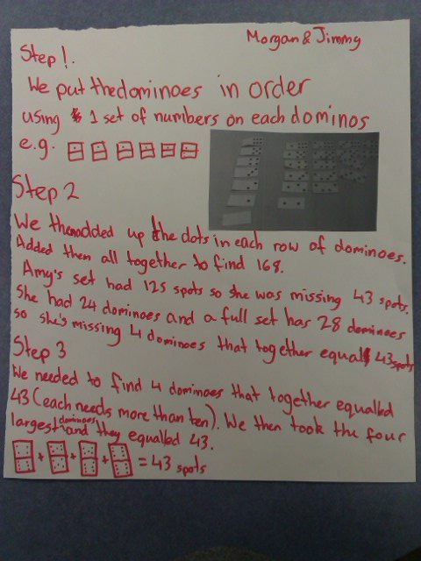

Khubaib and Jerry
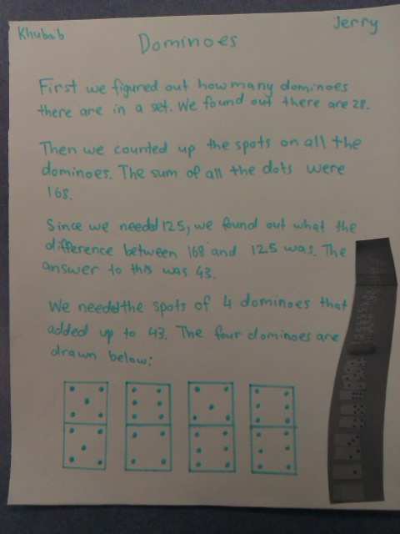

Tekla and Cate
