Thanks to Jack S for the diagrams!

Shape 1

Jack S: Number 1 is 1/8 because you can split the picture into quarters so half of the space taken up is an eighth.

Abi, Maddie and Zoe: The answer is 1/8 because 8 times number 1 is the whole 1x8= 1 whole.

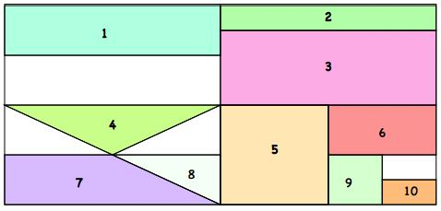
Matthew: It’s 1/8 because it’s half of ¼ and you can fit 8 of them into the whole shape.

Shape 2

Jack S: Number 2 is a 1/16 because if number 1 is an eighth, then number 2 is half the size so it’s a sixteenth.

Abi, Maddie and Zoe: The answer is 1/16 because number 2 is exactly half of number 1 so you have to double the denominator to equal the whole.

Matthew: its 1/16 because it is half of number 1 and you can fit 16 of them in altogether.

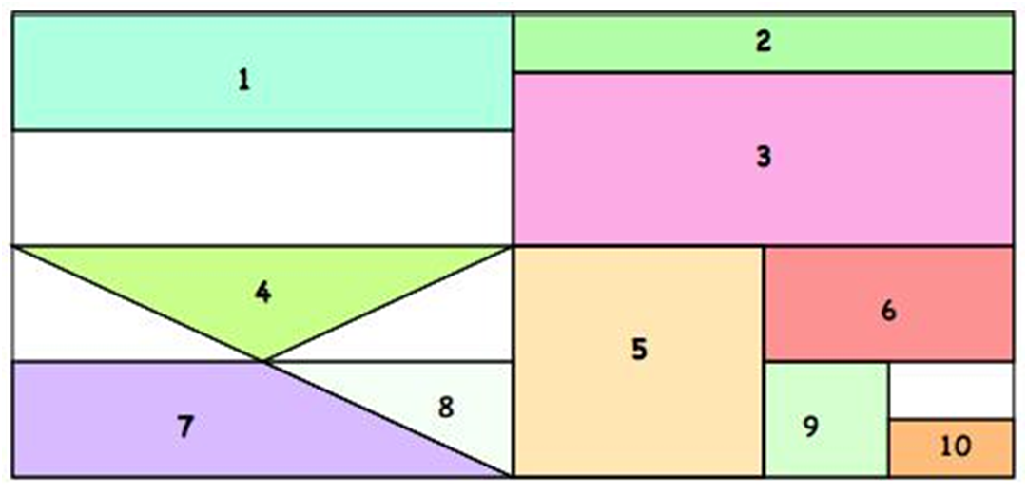

Shape 3
Jack S: Number 3 is 3/16 because when the shape is split into quarters, the shape takes up ¾ of a quarter, so it’s 3/16.

Abi, Maddie and Zoe: The answer is 3/16 because we have worked out number 2 is 1/16 and number 3 is 3 times that so its 3/16.
Also 1/16 add 3/16 equals ¼ so and number 2 and 3 equals ¼ of the whole.
Matthew: its 3/16 because it is the same as 3 lots of the number 2.

Shape 4
Abi, Maddie and Zoe
The answer is 1/16 because the quarter where number 4 is in can fit number 4 in 4 times so 4x4= 16

Shape 5
Jack S: Number 5 is an 1/8 because if the whole shape is split into quarters, then half of a quarter is an eighth.

Abi, Maddie and Zoe: 1/8 because 2 times that shape equals the quarter so 8 times the shape is the whole.
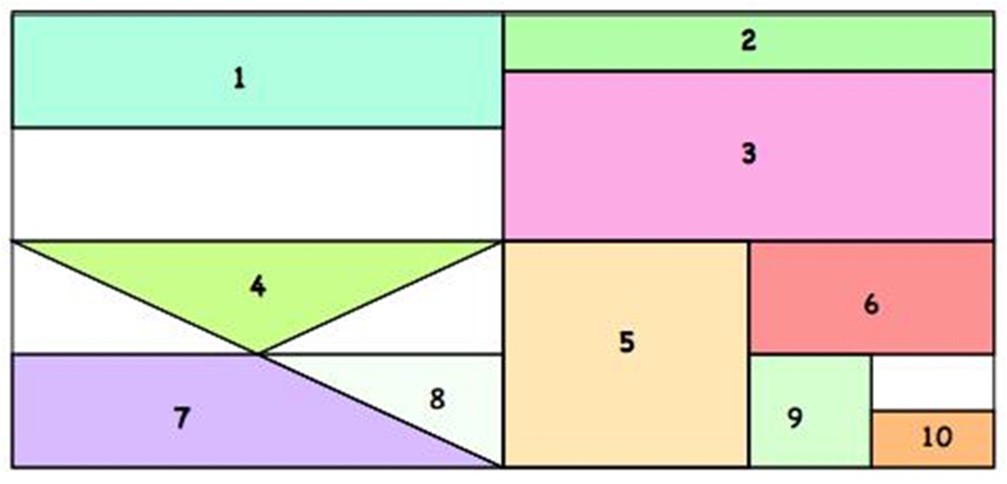

Abi, Maddie and Zoe:
Shape 6
1/16 because it is half of number 5 so you double the denominator.
Shapes 7 & 8
Shape 8 is 1/32 because 32 lots of this shape equals the whole. Shapes 7 and 8 together is the same as shape 1, which is 1/8.
Shape 7 is ¾ of the 1/8 and shape 8 is ¼ of the 1/8. So shape 7 is 3/32 because it is three times number eight, which is 1/32.
Shapes 9 & 10
9 is half of 6 so you double the denominator. It is 1/32 which is the same as shape 8.
10 is half of 9, so you double the denominator, making 1/64.

