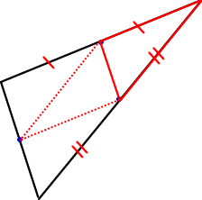

Why are the triangles congruent?

To use in conjunction with Triangle Mid Points http://nrich.maths.org/public/viewer.php?obj_id=483

