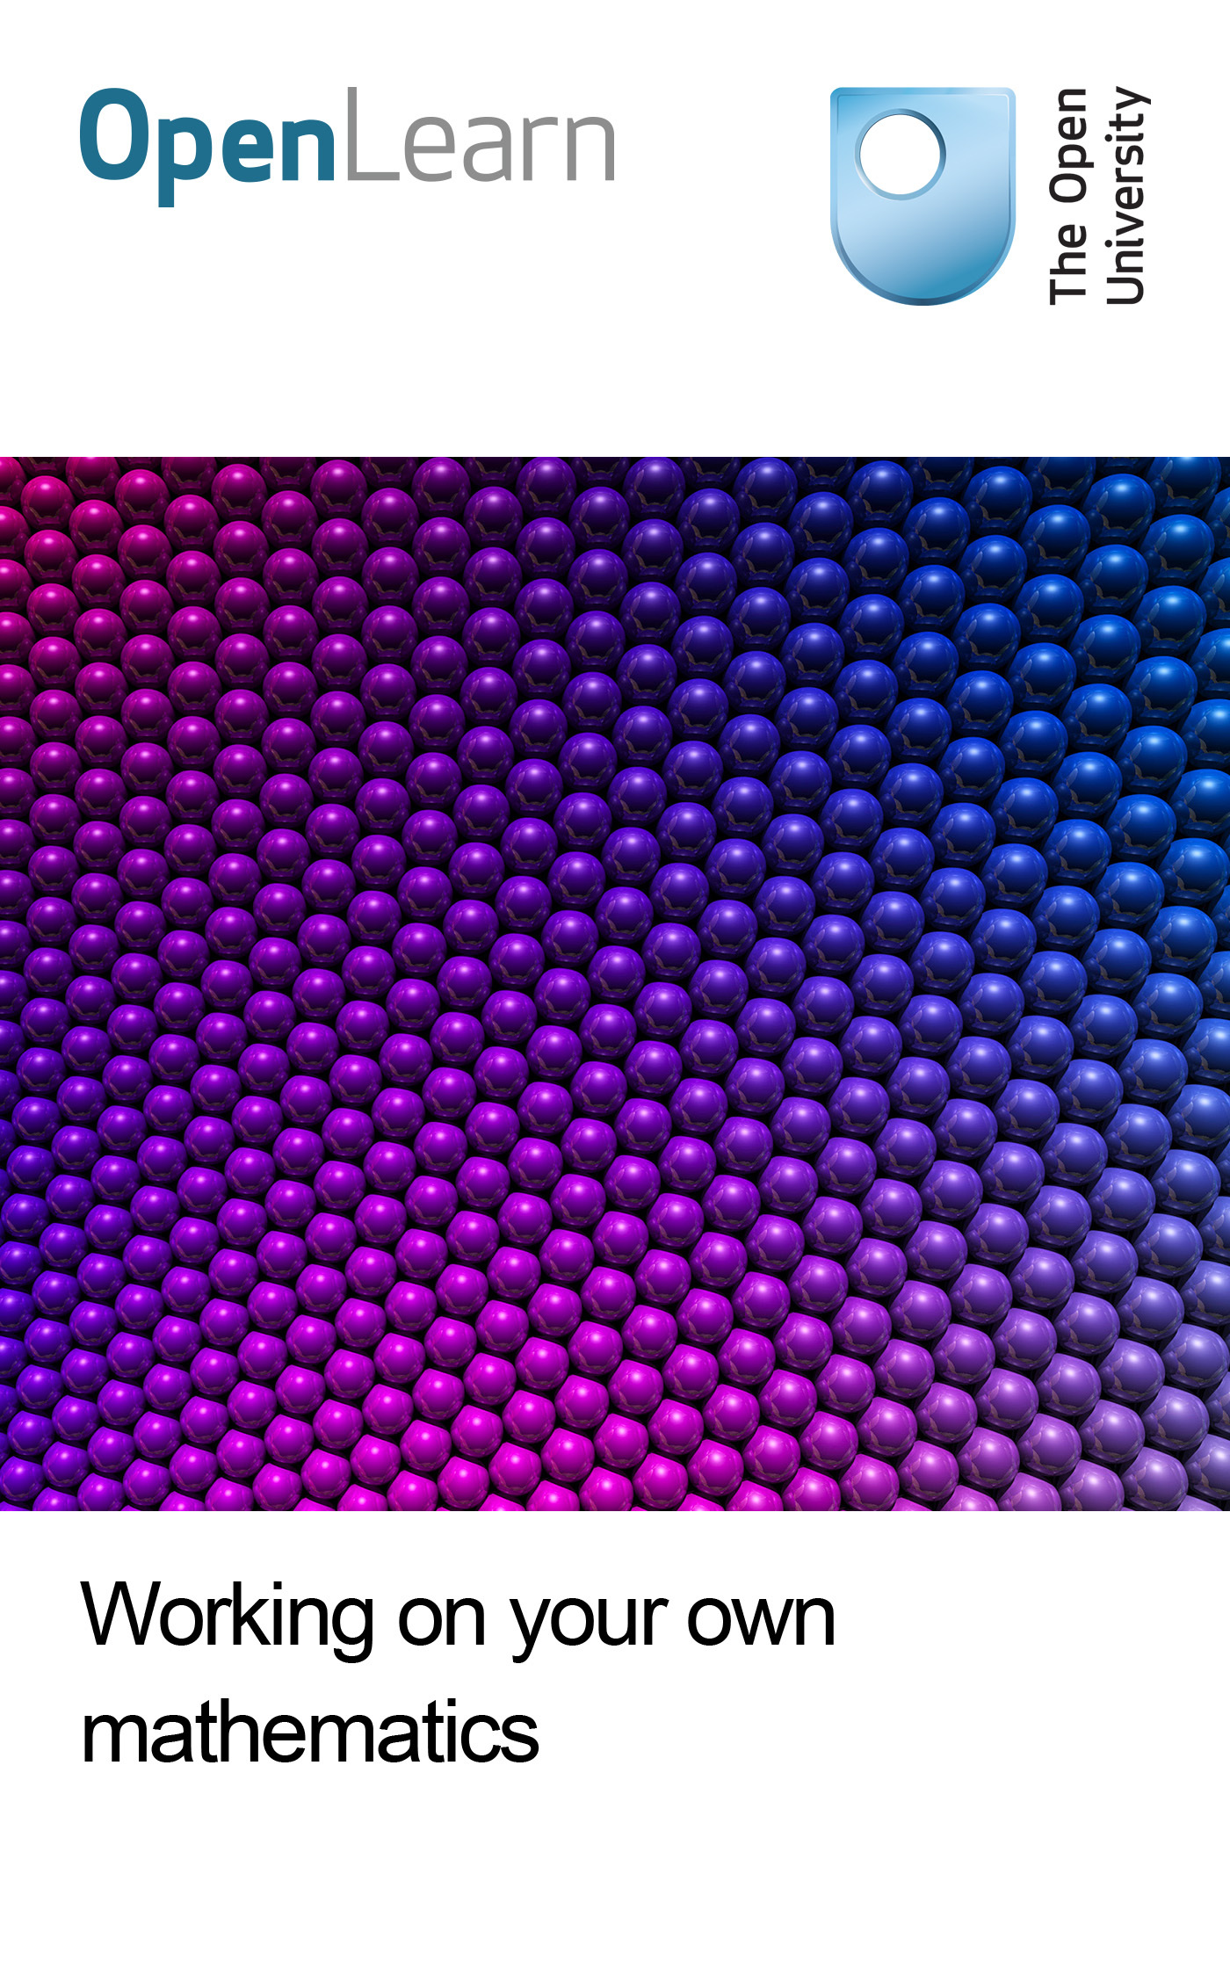

ME825_1

Working on your own mathematics
About this free course
This OpenLearn course provides a sample of postgraduate level study in Education and Mathematics.
This version of the content may include video, images and interactive content that may not be optimised for your device.
You can experience this free course as it was originally designed on OpenLearn, the home of free learning from The Open University: www.open.edu/openlearn/science-maths-technology/mathematics-and-statistics/mathematics-education/working-on-your-own-mathematics/content-section-0.
There you’ll also be able to track your progress via your activity record, which you can use to demonstrate your learning.
The Open University, Walton Hall, Milton Keynes MK7 6AA
Copyright © 2016 The Open University
Intellectual property
Unless otherwise stated, this resource is released under the terms of the Creative Commons Licence v4.0 http://creativecommons.org/licenses/by-nc-sa/4.0/deed.en_GB. Within that The Open University interprets this licence in the following way: www.open.edu/openlearn/about-openlearn/frequently-asked-questions-on-openlearn. Copyright and rights falling outside the terms of the Creative Commons Licence are retained or controlled by The Open University. Please read the full text before using any of the content.
We believe the primary barrier to accessing high-quality educational experiences is cost, which is why we aim to publish as much free content as possible under an open licence. If it proves difficult to release content under our preferred Creative Commons licence (e.g. because we can’t afford or gain the clearances or find suitable alternatives), we will still release the materials for free under a personal end-user licence.
This is because the learning experience will always be the same high quality offering and that should always be seen as positive – even if at times the licensing is different to Creative Commons.
When using the content you must attribute us (The Open University) (the OU) and any identified author in accordance with the terms of the Creative Commons Licence.
The Acknowledgements section is used to list, amongst other things, third party (Proprietary), licensed content which is not subject to Creative Commons licensing. Proprietary content must be used (retained) intact and in context to the content at all times.
The Acknowledgements section is also used to bring to your attention any other Special Restrictions which may apply to the content. For example there may be times when the Creative Commons Non-Commercial Sharealike licence does not apply to any of the content even if owned by us (The Open University). In these instances, unless stated otherwise, the content may be used for personal and non-commercial use.
We have also identified as Proprietary other material included in the content which is not subject to Creative Commons Licence. These are OU logos, trading names and may extend to certain photographic and video images and sound recordings and any other material as may be brought to your attention.
Unauthorised use of any of the content may constitute a breach of the terms and conditions and/or intellectual property laws.
We reserve the right to alter, amend or bring to an end any terms and conditions provided here without notice.
All rights falling outside the terms of the Creative Commons licence are retained or controlled by The Open University.
Head of Intellectual Property, The Open University
Edited and designed by The Open University
Printed in the United Kingdom
978-1-4730-1385-8 (.kdl)
978-1-4730-0617-1 (.epub)

Contents
- Introduction
- Learning outcomes
- 1 Forces for development
- 2 Your own mathematics
- 3 Work on your own mathematics
- Conclusion
- Keep on learning
- References
- Acknowledgements

Introduction
This course focuses on your initial encounters with research. It invites you to think about how perceptions of mathematics have influenced you in your prior learning, your teaching and the attitudes of learners.
This OpenLearn course provides a sample of postgraduate level study in Education and Mathematics.

Learning outcomes
After studying this course, you should be able to:
- reflect in depth on aspects of mathematics learning, whether personally directly concerned with mathematics teaching or simply interested in issues of mathematics education
- examine established views about existing practice in a critical way and engage with research evidence on mathematics and learning.

1 Forces for development
Working in mathematics education involves a sense of both past and future, and how the two combine to influence the present. It may seem that, because the past has already happened, it cannot be altered; however, you can alter how you perceive the past, and what lessons you take from it. Each of us has a personal past in mathematics education—the particular events of our personal lives, who taught us, where, what and how they taught us, and what we took from the experiences. Each of us also has a related ‘communal’ past—the general events in mathematics education and their influences on school practices, as well as the perceptions of mathematics and school in the cultures in which we grew up. The past exerts a serious grip on the present, helpfully in terms of maintaining tradition and continuity across generations, and unhelpfully for the same reasons.
A colleague, Christine Shiu, was in China talking with a group of mathematics teachers about problem solving and investigative work in mathematics. One commented ‘Yes, but you must learn from the Ancestors first’. One reason for attending school is to become one of those who know the old ways, and so be part of a ‘community of memory’ and hence an inheritor of traditions. There is perhaps no more fundamental split between a perception of the primary function of schooling as enculturation into traditions, and a perception of schooling as preparation for the future; this is often unfairly characterised as a split between the backward-looking and the forward-looking, with all the connotations of those words.
The future too can exert a strong influence. Again, it might seem strange that the future can exert an influence on the present. But you have a more or less explicitly desired personal future that affects what and how you teach, and part of the work of mathematics education is to envisage possible communal futures for mathematics teaching and learning. A particularly relevant aspect of communal thinking about the future of mathematics education concerns the influence of technologies, especially computers, and their potential to destabilise radically some traditional views of the interactions among teachers, learners and mathematics in a classroom setting.
This section focuses on your own and others’ accounts of their experiences of learning mathematics. It begins to show how such personal experiences can be explored and can inform the shared communal culture of published writing.
Everybody can remember incidents from their own learning of mathematics. Some incidents may be positive and others negative. What influence might such memories have on the teaching and learning of mathematics?

Activity 1 Starting your mathematical autobiography

Think back over your own experiences of learning mathematics, both as a child and as an adult. What stands out for you? It might be particular incidents, particular lessons, particular teachers, or a generalised sense of some sort, or an emotional response, or it might be all of these, and much more.

View discussion - Activity 1 Starting your mathematical autobiography

Activity 2 Forces for development

Read the chapter Forces for development. This is taken from the book Researching Your Own Practice. In this chapter, John Mason, a member of the ME825 course team, looks at some of the forces for development in mathematics education and introduces reflection as an action. As part of your reading, you are invited to carry out a personal inventory and an inventory with colleagues.

2 Your own mathematics
It is crucial to remember that you are a learner of mathematics as well as a teacher. In this course you will be asked to undertake some mathematical tasks. The aim of these tasks is not to improve your mathematics, but to give you experience of doing mathematics for yourself—experience that you can reflect upon subsequently. The reflection is used to develop your awareness of the ways that learners deal with mathematical tasks, and how learners' mathematical thinking is influenced by the ways that tasks are formulated.
Moreover, it is important that you develop the habit of working on mathematics for yourself so that you refresh your awareness of how easy it is to get stuck on a problem, and how learners can use their powers of mathematical thinking to get themselves unstuck.

3 Work on your own mathematics
Two activities are given below. You are asked to work on them in turn and to record not only your working, but observations on what you notice about your emotions as you work through step by step.

Activity 3 Constrained numbers

Work on this task for about half an hour.
Starter
Write down a number between 2 and 4. And another. And another.

View discussion - Activity 3 Constrained numbers

Activity 4 Main task

Write down a decimal number that lies between 2 and 3.
Now add a further constraint. Write down a decimal number that lies between 2 and 3, and does not use the digit 5.
Now add a further constraint. Write down a decimal number that lies between 2 and 3, and does not use the digit 5 but does use the digit 8.
Add a further constraint. Write down a decimal number that lies between 2 and 3, and does not use the digit 5 but does use the digit 8, and is as close to 2½ as possible.
Variant 1
Write down a fraction between 4 and 5.
Write down a fraction between 4 and 5 that uses each digit 0 to 9 just once.
Write down a fraction between 4 and 5 that uses each digit 0 to 9 just once and is as close to 4.25 as possible.
Variant 2
Write down a three-digit number.
Write down a three-digit number whose digits are all distinct.
Write down a three-digit number whose digits are all distinct and whose digits are all odd.
Write down a three-digit number whose digits are all distinct, whose digits are all odd and which is not a multiple of 5.
Now go back and, at each stage, write down a three-digit number that does not meet the criteria which follow it. For example, your first number must not have all digits distinct.

View discussion - Activity 4 Main task

Activity 5 Greatest common divisor

Work on this task for about an hour. Keep a record of significant moments as well as of your working on the mathematics.
Write down a pair of numbers such that one number is over 50 and the other is between 30 and 50. Subtract the smaller number from the larger one. From a new pair of numbers consisting of the smaller number and the difference. Repeat this until you get a difference of zero. The number just before you get zero should be the greatest common divisor of your starting numbers.
The greatest commom divisor of two numbers is the largest number that will divide exactly in to each of them.

Activity 6 Carriage wheels

Work on this task for about half an hour. What connections can you see with Activity 4?
A horse-drawn carriage used in parades has back and front wheels of different sizes, as shown in the figure below. The large back wheels are 165 cm in diameter, and the smaller front wheels are 121 cm in diameter. How many revolutions of each are required before the points touching the ground on all wheels are again all touching the ground? Explore this question for different-sized wheels, such as 165 cm and 66 cm, or 180 cm and 40 cm
The greatest common divisor of two numbers is the largest number that will divide exactly in to each of them.

View discussion - Activity 6 Carriage wheels

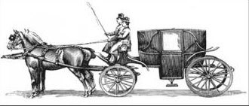

Conclusion
This free course provided an introduction to studying Mathematics. It took you through a series of exercises designed to develop your approach to study and learning at a distance and helped to improve your confidence as an independent learner.
This OpenLearn course provides a sample of postgraduate level study in Education and Mathematics.

Keep on learning



Study another free course
There are more than 800 courses on OpenLearn for you to choose from on a range of subjects.
Find out more about all our free courses.

Take your studies further
Find out more about studying with The Open University by visiting our online prospectus.
If you are new to university study, you may be interested in our Access Courses or Certificates.

What’s new from OpenLearn?
Sign up to our newsletter or view a sample.

For reference, full URLs to pages listed above:
OpenLearn – www.open.edu/openlearn/free-courses
Visiting our online prospectus – www.open.ac.uk/courses
Access Courses – www.open.ac.uk/courses/do-it/access
Certificates – www.open.ac.uk/courses/certificates-he
Newsletter – www.open.edu/openlearn/about-openlearn/subscribe-the-openlearn-newsletter

References
Hart, K., Kerslake, D., Brown, M., Ruddock, G., Kuchemann, D. and McCartney, M. (eds) (1981) Children's Understanding of Mathematics 11-16, London, John Murray.
McCague, W. (2003) 'A mathematical look at a medieval cathedral', Math Horizons, April, pp.11-15 and p.31. See also http://www.maa.org.
Phillips, E. and Crespo, S. (1996) 'Devopling written communication in mathematics through math penpal letters', For the Learning of Mathematics, vol.16, no.1, pp. 15-22.

Acknowledgements
All materials included in this course are derived from content originated at The Open University.
Course image: fdecomite in Flickr made available under Creative Commons Attribution 2.0 Licence.
Don't miss out:
If reading this text has inspired you to learn more, you may be interested in joining the millions of people who discover our free learning resources and qualifications by visiting The Open University - www.open.edu/openlearn/free-courses
This free course is adapted from a former Open University course: ME825 Researching mathematics learning.

Activity 1 Starting your mathematical autobiography

Discussion
Wait until you have some spare time and feel willing to be introspective. Start making some notes in response to this task, and continue adding to them. Starting to think about your experiences may produce memories you had forgotten. Be prepared to be surprised, and possibly disquieted or even distressed by some of your recollections. Learning mathematics has seldom been a neutral experience.
Back to Session 1 Activity 1

Activity 3 Constrained numbers

Discussion
Experience suggests that there is a significant difference between being asked for three examples all at once, and being asked for three one after the other with pauses for the construction at each stage. By the third request, many learners are ‘feeling bored’ and so challenge themselves by constructing more complex examples. The point of the task is to get learners to become aware of the range of choices open to them and, more specifically, the general class of possibilities from which they can choose, so they do not jump at the first thing that comes to mind
Back to Session 3 Activity 1

Activity 4 Main task

Discussion
Did you find that working with each constraint in turn made it easier to construct an appropriate example than if you had tried to meet all the constraints at once? Were you tempted to jump ahead and try to be efficient by just doing the last part of each task? The idea behind setting a task in this way is that at each stage you become aware of the range of possibilities from which you are choosing your particular example. The last part of Variant 2 is designed to reveal examples that are more constrained than they need to be, and so it should lead to an awareness of a range of permissible examples that arise when one or other feature of the number is varied.
Experience suggests that, in the classroom, reading the task out stage by stage, leaving time for construction at each stage, is much more effective than asking for ‘three examples’ all at once. When several people are doing the task together, they can check each other's examples to make sure that they meet the constraint.
Back to Session 3 Activity 2

Activity 6 Carriage wheels

Discussion
Did you wonder why those numbers were chosen for the diameters of the carriage wheels? How easy was it to devise other pairs of wheel sizes that posed similar problems? Were you able to see a connection with Activity 4?
Back to Session 3 Activity 4

