If we go to the point when the first square ABCD has been enlarged to EFGH we get this picture:-

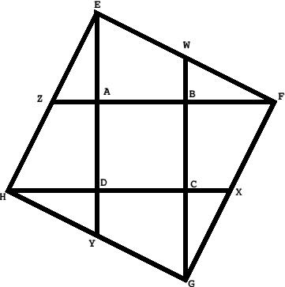

We have some geometric facts which can be derived. I'm putting these into the notes because if you are working with particularly able pupils you may need to get a glimpse of these relationships.

1. Pythagoras gives us the relationship at AF squared added to AE squared will give us EF squared.

2. AB has been extended by the same length again so that AF is twice as long as AB.

3. AE is the extension of AD and so the two are the same length.

It's nice to take the lengths of the sides of the inner square as 1.

So we see that AF is 2, AE is 1 and using that realization of Pythagoras be have:

1^2 + 2^2 = EF^2

1 + 4 = 5

So the length of EF is the square root of 5 which is 2.236 ish.
But we can just call it "root 5" all the while.
You may find that some of these pupils look at areas.
The area of ABCD is 1 sq unit
The area of EFGH is root 5 multiplied by root 5 so is 5!
The areas of subsequently larger squares increases by powers of 5 as the lengths of the sides increase by powers of root 5.

ALSO from the same picture:-

Interesting discussions are to be had with pupils who have some idea that Triangle BFW will swing around point W to fit on top of EABW so as to form a square E (now with F) AB and the moved B from the small triangle.

Some pupils can treat this very usefully as a jigsaw and cut it out carefully. Others may well use their intuition and others their knowledge to get there.

Other ways of moving pieces around can be seen here, which shows that the larger square is 5 times the smaller one without too much difficult construction.

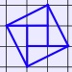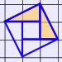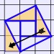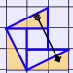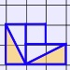

When they have got there you can see the fact that the larger square is equivalent in area to 5 of the smaller squares.

So we have done a construction that is fairly simple. Now look at it the other way round and we have a large square in which 4 lines have been drawn from the centre of each side to the appropriate opposite corner. Now we also know that the area of the smaller square is 1/5 of the larger. So, we can now be presented with a square and be able to generate the square that has an area 1/5 of the original!

Some pupils might like to investigate extending the sides of the original square by a line 2x or 3x that length.

Finally, I have not actually done the last bit with pupils but I see that there can be great fun and discovery with acetate sheets of the root 5 sided square placed over a whole array of smaller squares of size 1.

This really has great potential for KS 2 3

