Here are some shapes I drew on a dotty grid:
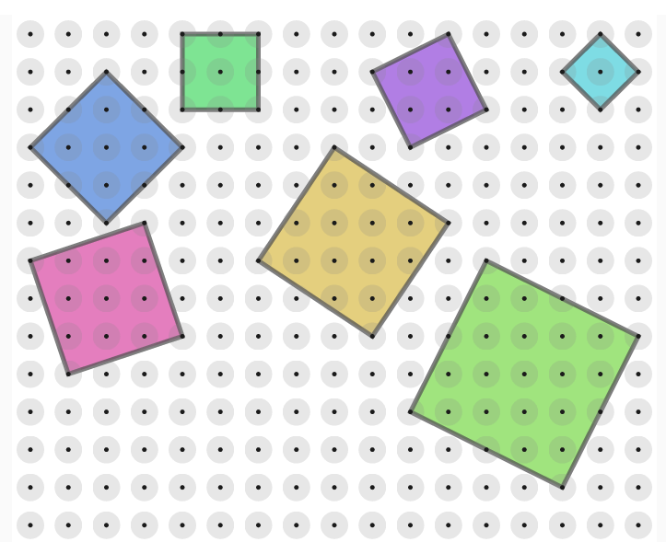

Are they all squares?
What other shapes can I draw?
Can I start with any two dots?
Can I draw other regular polygons?
What is the area of the squares?

What about Rhombuses? 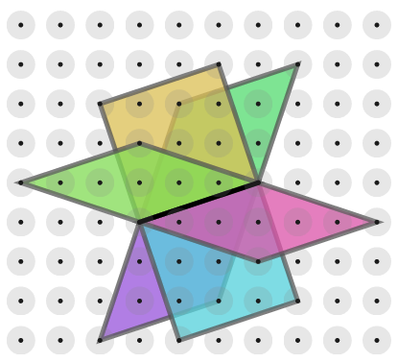

How many rhombuses are there?
Choose two dots of your own.
How many rhombuses can you draw?
What do you notice about the rhombuses you have drawn?

