Here are some squares and their diagonals:
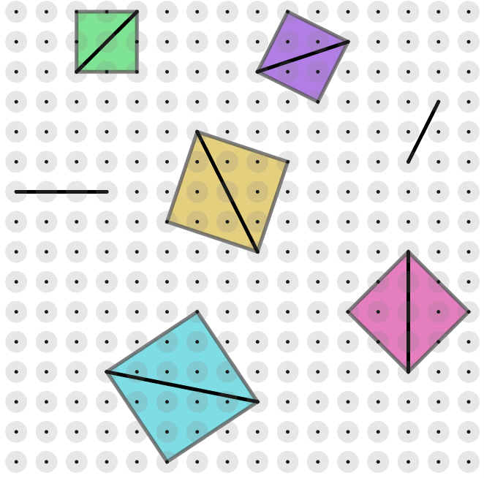
Join any two dots to form a diagonal. Can you draw the surrounding square?
When will all four corners be on dots?

Here are some rhombuses that share a diagonal.
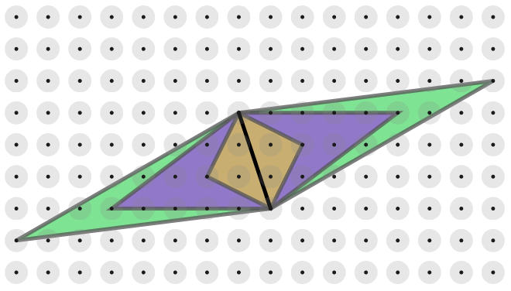

Join any two dots to form a diagonal. How many rhombuses can you draw?

