Charlie drew some squares:

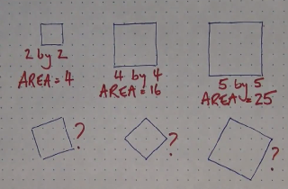

He found it quite easy to work out the area of the squares at the top.

Is there an easy way to work out the area of the tilted squares?

