The shapes below all have two dots inside and six dots round the edge.
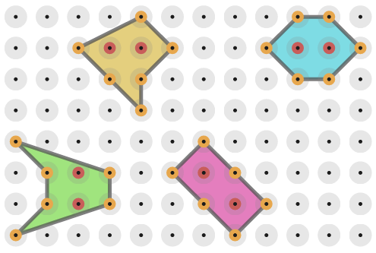

What do you notice about the areas of the shapes?

Draw some shapes of your own.
Is there an easy way to work out the area of a shape if you know the number of dots on the edge and the number of dots inside?

