Take an 8 by 8 square, and cut it up like this:
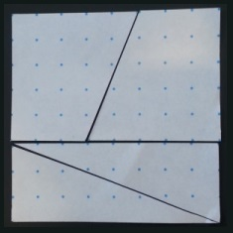

Rearrange the pieces to make a 13 by 5 rectangle:
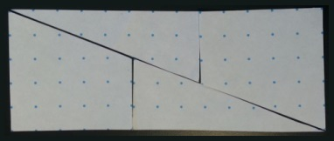

It seems we can use the same pieces to make two shapes with different areas! Can you explain why?
Can you perform this “magic trick” by splitting squares of other sizes in a similar way?

