Six Numbered Cubes
The aim of this challenge is to find the total of all the visible numbers on the cubes.
We are using six cubes.
Each cube has six faces of the same number.
.
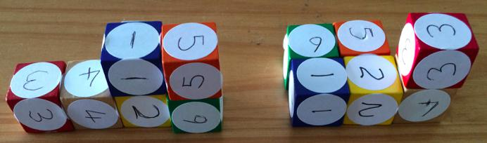
The "wall" has to be only one cube thick.
The one on the left is built correctly by being a wall only one cube thick.
The one on the right is NOT allowed as it is two bricks thick in parts.
The cubes sit neatly - square face against square face.
The total on the left one is 70.

CHALLENGE 1
Start by making a staircase shape. An example is shown below:
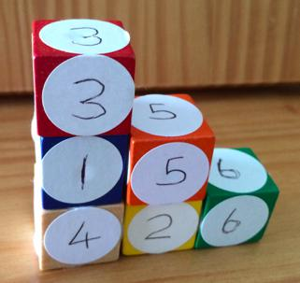
a/ What is the highest total you can make by using this staircase shape?
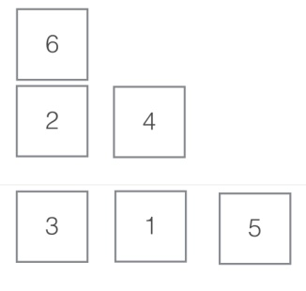
The highest total you can make is 83. You get this answer by putting the highest numbers on the places which have the most faces shown. This is how you get it

b/ What is the lowest total you can make by using this staircase shape?
To get the lowest total you just do the opposite to Q.1 The answer is 64.
This is how you can get to it.
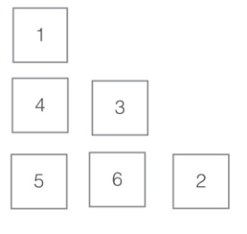

c/ Explain in writing how you calculated the totals for a & b above, making sure you give reasons for your method/s.
See above.
d/ Now make a total of 75 using a staircase shape.
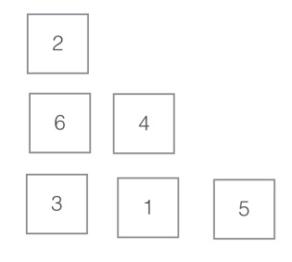
There are many ways to do this problem (including the example) but I did it by starting from the answer from question 1 then I swapped around some of the numbers to get 8 less. This is how I did it.

CHALLENGE 2
Using any shape of single cube thickness, what is the lowest total you can make?
How can you be sure this is the lowest total whatever the shape?
Can the lowest total be found in more than one way? Justify your answer.
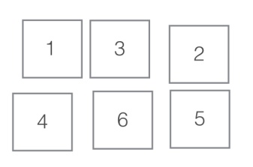
The first step to completing this problem is to find the shape with the least amount of visible faces. This is a 3x2 rectangle on its long edge. This is the correct solution. You can find many different ways by changing the numbers around as long as they are in places that have the same amount of visible faces

CHALLENGE 3
Using any shape of single cube thickness, what is the highest total you can make?
How can you be sure this is the highest total whatever the shape?
Can the highest total be found in more than one way? Justify your answer.
This is the opposite to the last problem as you have to find the shape that has the most visible faces. It is a 1x6 tower on its short edge. This is the correct solution. As with the last question you can swap any of the bottom 5 numbers around.

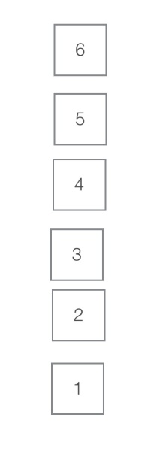

CHALLENGE 4
Prove the following by logical reasoning, rather than by calculating the answers:
If the cubes are arranged in a single vertical tower (like this)
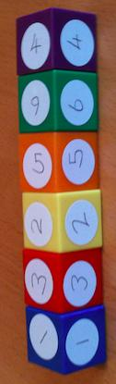
then whatever the order of cubes you cannot produce a total of 80.
This problem seems to be very hard at first but the more you look at it the easier it becomes. The first time I did this I did it a very complicated way but there is one surprisingly easy solution. The answer is that the addition doesn't add up (literally). If you reverse the digits from the last question you will get the smallest possible answer which is 85. So there is no way that you can make it add up to 80. That is how you do it the simple non complicated way but you can do it many other ways too.

