Swimming Pool Tiles Investigation by Tom (Stourport Primary Academy Y6)
I decided to investigate the 4 times table and discovered a diagonal pattern.

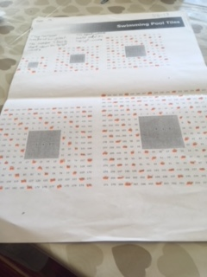

Next I decided to colour the 4s, 8s and 12s on the same grid. Exactly the same numbers were coloured because of course the 8 and 12 times tables are also multiples of 4.
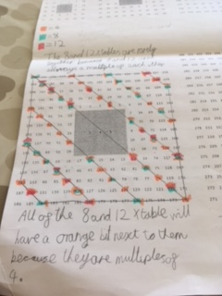
I also spotted that if you join up the diagonal lines and join up the sides you make 6 isosceles trapeziums.
This lesson was one of my favourite ever maths lessons.

Daisy (Y6 Stourport Primary Academy)

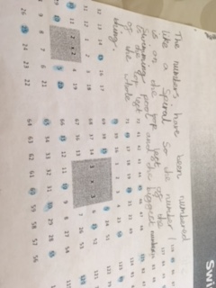
The following photos show some of the patterns I discovered when I tried the Swimming Pool Tiles problem.
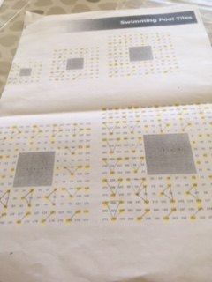
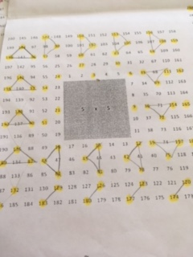
I couldn’t see an obvious pattern to the 5 times table, but once I had highlighted all the numbers in the 3 times table I noticed that you could join these up in groups of 3 to make a pattern or rotating triangles. Here’s a close up to show you what I mean.

After I had completed this I wondered why there was this obvious pattern of triangles with the 3 x table but no obvious pattern with the 5 x table. I wonder whether there would be a clearer pattern if I tried the 5 x table on a bigger grid?

My solutions to Swimming Pool Tiles by Lois (Stourport Primary Academy Y6)
I decided to colour all the multiples of 9 on the different sized grids. I noticed that if you join all the numbers with lines (so you would join 9 to 18, then 18 to 27 and so on), there is a pattern where it makes a spiral of shapes. It goes from a triangle to a square to a pentagon and so on so the shapes within the spiral increase by 1 corner each time.
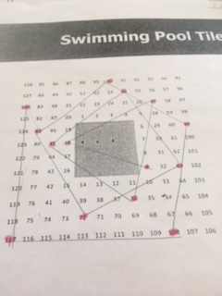
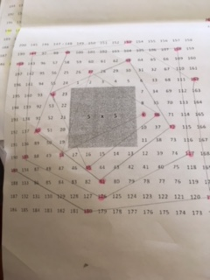
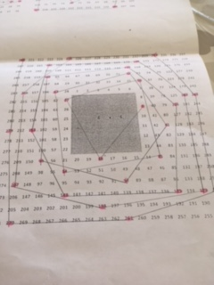
Here are the photos of my work to prove it!

Originally I had made a prediction that odd numbered times tables wouldn’t have a pattern. I was wrong!

Swimming Pool Tiles by Keira (Y6 Stourport Primary Academy)
Most of my friends said that there isn’t a pattern for the 5 x-table but I thought you could group the highlighted numbers together and make petals on a flower like this.
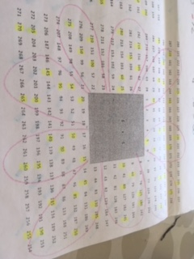
My group had a go, with help from our teacher, at working out how you could predict how many tiles would be needed to go around different pool sizes.
One of my friends spotted that if you multiply the area of the pool by 8 you get the number of tiles needed to go around it.
For example if the pool is 3 x 3 you would do 3x3=9 then multiply 9 by 8 which gives you 72 tiles. We checked this with all the tiles on the sheet and found this to be true. Then we used the same formula to calculate how many tiles would surround a pool that 100 x 100.
100 x 100 = 10000.
10000 x 8 = 80000. We decided not to have a go at drawing that one!

