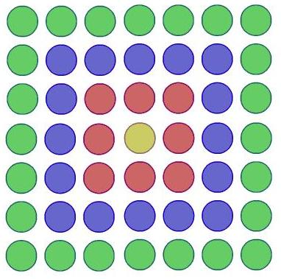
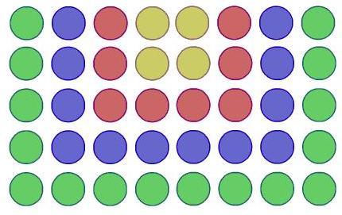
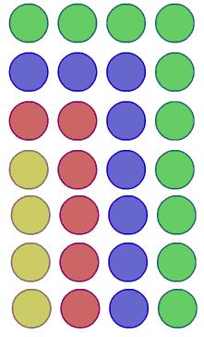
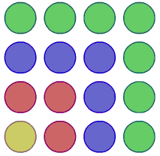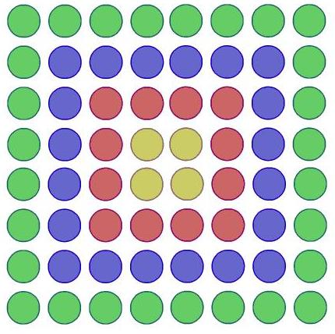
This follows on from the NRICH problem
“Picturing Square Numbers” available on www.nrich.maths.org

We have just seen that the sum of odd numbers can be represented as a square array of dots.
The square diagram can be adapted to represent related summations.
Design your own, or use some of ours, and make notes on:

- How it was built from the original square array.
- How many dots there would be in the 100th diagram (ie the one with 100 colours).
- What summation it represents.
- Whether there are alternative ways of expressing the summation, relating to different ways of looking at the diagram.

