Growing Rectangles

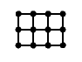
This rectangle has height 2 and width 3.
Work out (a) the perimeter (b) the number of dots and (c) the number of lines needed to draw a rectangle with:
height 2 and width 25
height 2 and width 100
height 2 and width n

……...…………………………………………………………………………………...............................

L Shapes

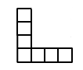
This L shape has height 4 and width 4.
Work out (a) the perimeter (b) the number of squares and (c) the number of lines needed to draw an L shape with:
height 25 and width 25
height 100 and width 100
height n and width n
……...…………………………………………………………………………………...............................

Two Squares

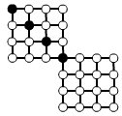
This pattern with two squares has four black dots.
Work out (a) the number of white dots and (b) the number of lines needed to draw a pattern with:
25 black dots
100 black dots
n black dots
Square of Squares

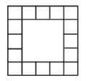
This pattern has side length 5.
Work out (a) the number of edge squares and (b) the number of lines needed to draw the pattern with:
side length 25
side length 100
side length n
……...…………………………………………………………………………………...............................

Dots and More Dots

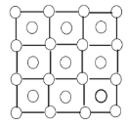
This pattern has side length 3.
Work out (a) the number of dots and
(b) the number of lines needed to draw the pattern with:
side length 25
side length 100
side length n

……...…………………………………………………………………………………...............................

Rectangle of Dots

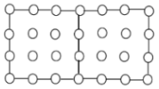
This pattern is made from two joined squares with side length 3.
Work out (a) the number of lines and
(b) the number of dots needed to draw the pattern of joined squares with:
side length 25
side length 100
side length n

