Painted Cube

Imagine a large cube made up from 27 small red cubes.

Imagine dipping the large cube into a pot of yellow paint so the whole outer surface is covered, and then breaking the cube up into its small cubes.

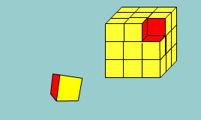

How many of the small cubes will have yellow paint on their faces?

Will they all look the same?
Now imagine doing the same with other cubes made up from small red cubes.
What can you say about the number of small cubes with yellow paint on?

Record your findings ready to present them to the rest of the class.

