

Sarah, Danielle and Sally said:
“We noticed that 17 works as when there are only two of them they get 8 each, with one left over. But when their friends come along they get three each with 2 left over.
We also notice that 7 works and 27 works, as well as 107.”

Poppy began like this:
If the two children end up with one lolly it must be an odd number of lollies. Then 3 more children come making the total number of children 5. Say they had 1 lolly each when they shared them, the number of lollies would be 7 because 1 times 5 is 5 add on 2 for the left over ones and it makes seven. If we carry this on to 10 lollies each it shows:
1 lolly each- 7 lollies
2 lollies each- 12 lollies
3 lollies each- 17 lollies
4 lollies each- 22 lollies
5 lollies each- 27 lollies
6 lollies each- 32 lollies
7 lollies each- 37 lollies 8
lollies each- 42 lollies
9 lollies each- 47 lollies
10 lollies each- 52 lollies

Here is the start of Phoebe and Alice’s work: of
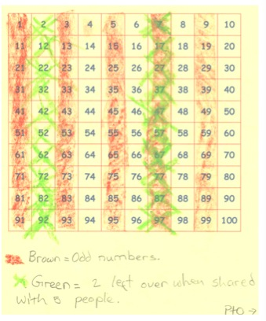

Can you take each of these starting ideas and develop each into a solution?

