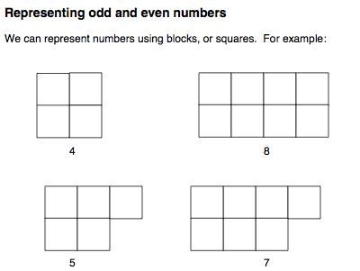
In even numbers, all the squares are paired, but in odd numbers there is one unpaired square.
Therefore:
- When an even number is added to an even number, the squares remain paired, and therefore an even number results.
- When an odd number is added to an odd number, the two unpaired squares can pair up, so an even number results.
- When an odd number is added to an even number, there is an unpaired square, so an odd number results.
- When an odd number is taken away from an odd number, no unpaired squares remain, so an even number results.
- When an even number is taken away from an even number, the squares remain paired, so an even number results.
- When an odd number is taken away from an even number, an unpaired square will remain, so an odd number results.
- When an even number is taken away from an odd number, an unpaired square remain, so an odd number results.

