Speeding Up, Slowing Down

Challenge: Can you now work out what produced the following speed / time graph?
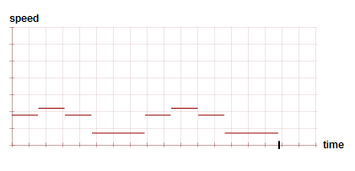
The rolling polygon had a radius of 30.
Can you work out how many sides it had and where the red dot was placed?
Try to explain how you worked it out.
Solution: A regular polygon which has a radius of 30 and 5 sides (pentagon) produced the speed/time graph. The dot was placed here on the pentagon: 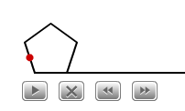

To work this out, I experimented with the interactivity first. By playing around with it I noticed several things. First of all, I noticed that no matter how many sides you had, if the dot was in the middle, the graph was a straight, horizontal line.
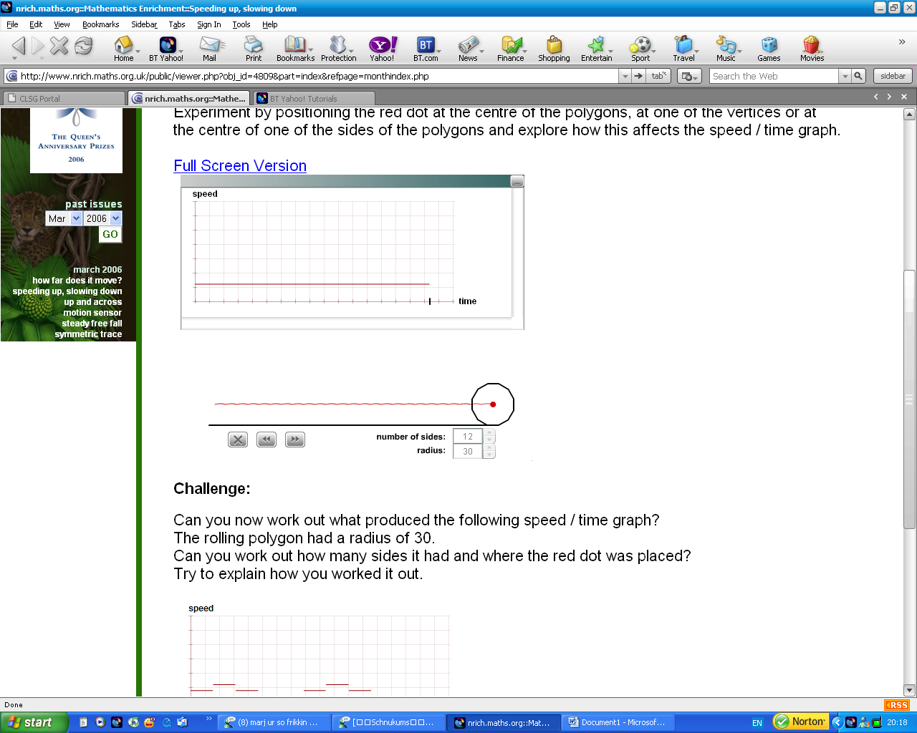

(The red dot is in the middle of the shape, and the line is straight and horizontal).

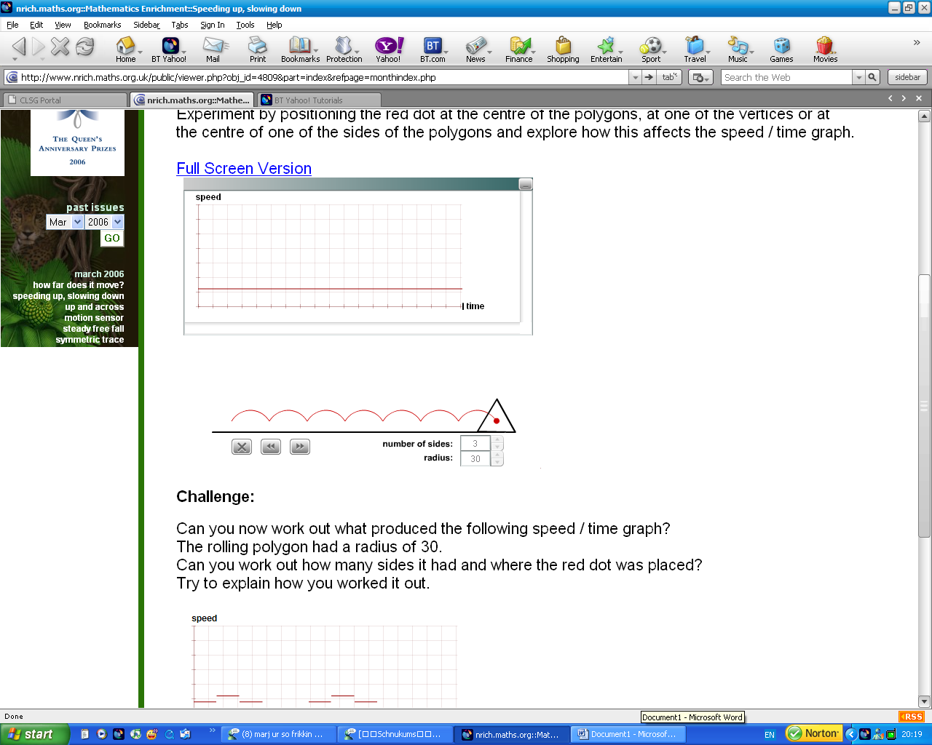
By working this out, I immediately knew that the dot couldn’t be in the middle of the shape, it had to be on one of the edges or vertices.
Then I found out that if you put the dot on one of the edges, the graph which is drawn has lines which go all over the place:
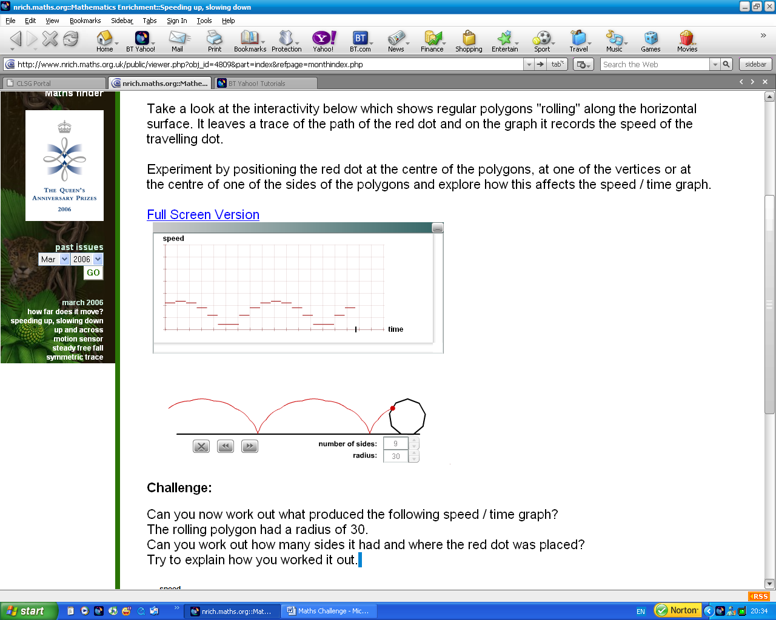

Then I tried to see what would happen if I put the dot on one of the vertices. Again, the lines were all over the place, but they were more evenly spaced.

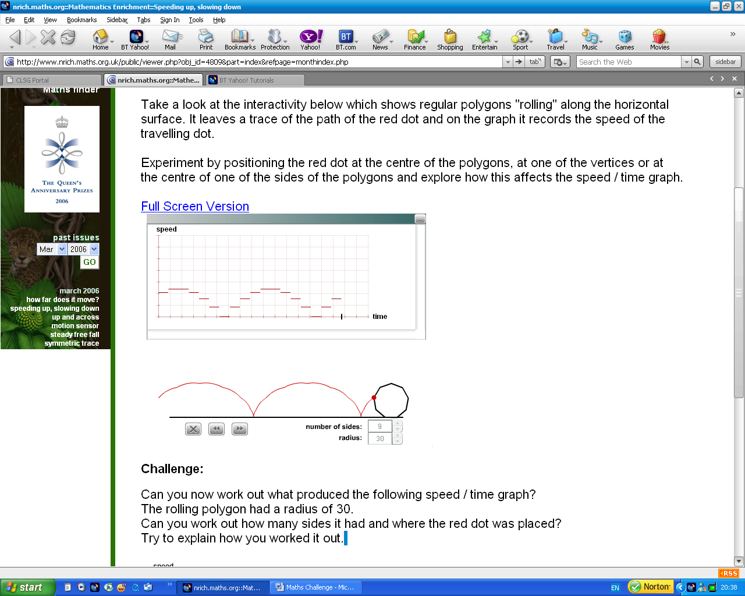

This made me realise that to make the graph in the challenge, the dot had to be on one of the edges. I thought this because if you look at the graph given in the question:
You will see that the lines are not evenly spaced. Therefore, so far, I knew that the dot had to be on one of the vertices. After further experimenting, I also worked out that each shape makes a different pattern, but they all have roughly the same structure. Each one has one extra long line at the bottom, and then smaller ones go up in the formation of stairs: (Below you can see what I mean in different examples)
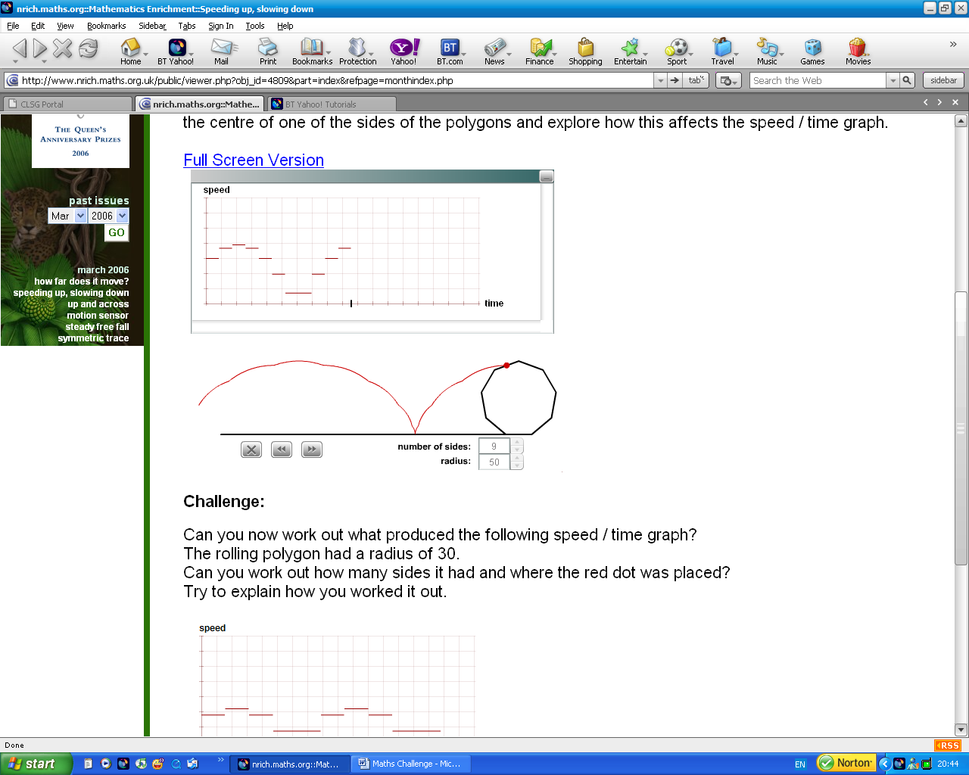
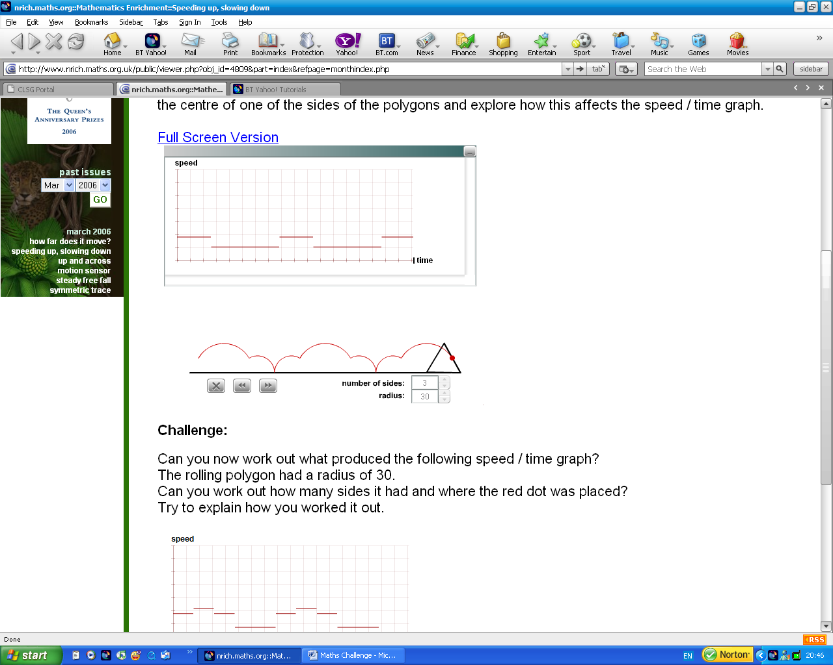

When I realised this, I also realised how to work out the number of sides a shape has from the graph it makes. If you see on all the examples, there is a recurring pattern of one long line (which is the bottom line) and then several smaller lines which are above the long lines. To work out the number of sides a shape has, you count the amount of lines there is in one sequence. One sequence begins at one of the big lines, and ends at the next big line.
Start End
You count the amount of lines in the sequence, including the first line and the last line. In the graph above, there are 3 lines in the sequence. This means that the shape has 3 lines.
Once I found this, I worked out from the graph that the shape had 5 sides.
Finally, I worked out that it mattered which edge you put the dot on. I put it onto each of the edges, and found that where the dot was put depended on what the graph looked like. For example, if you put the dot here:
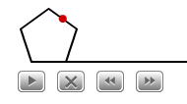
Then this graph was made:

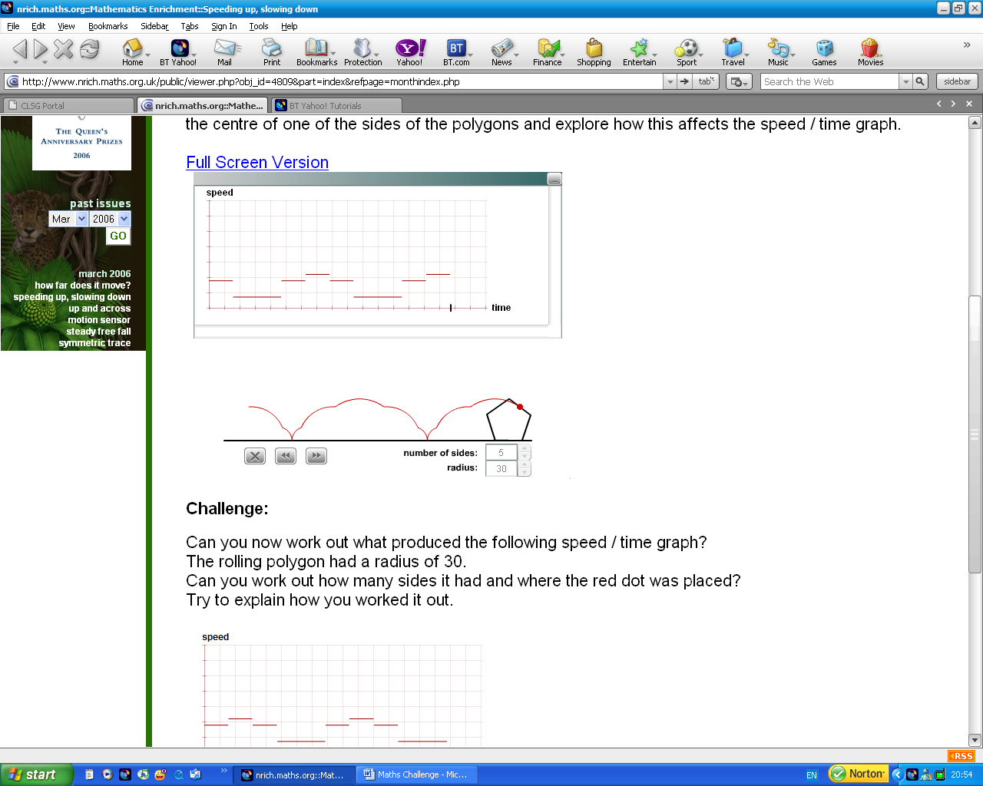
After testing all the edges, I worked out that the dot has to be put here:
