These triangles are in three different families:
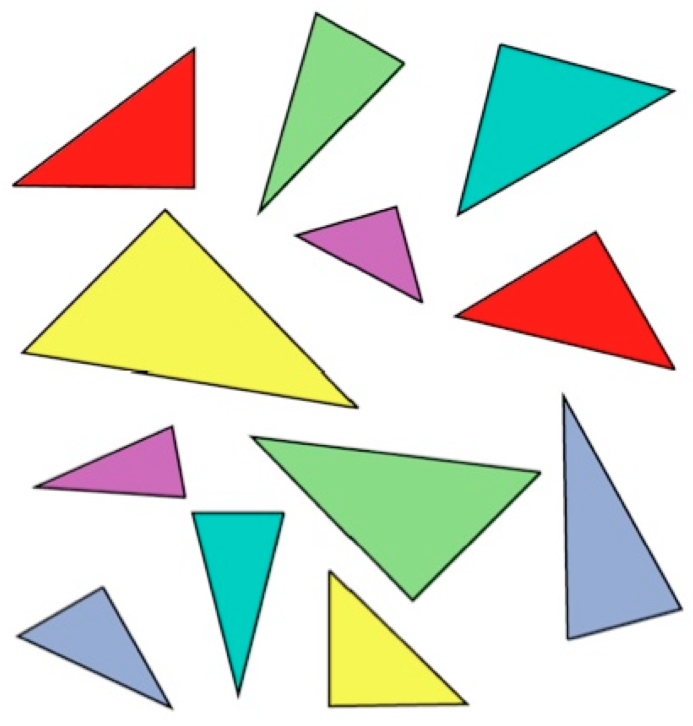

All the triangles in a family are the same shape, but they are not the same size or the same way up.
Can you sort them out?

These triangles are in three different families:
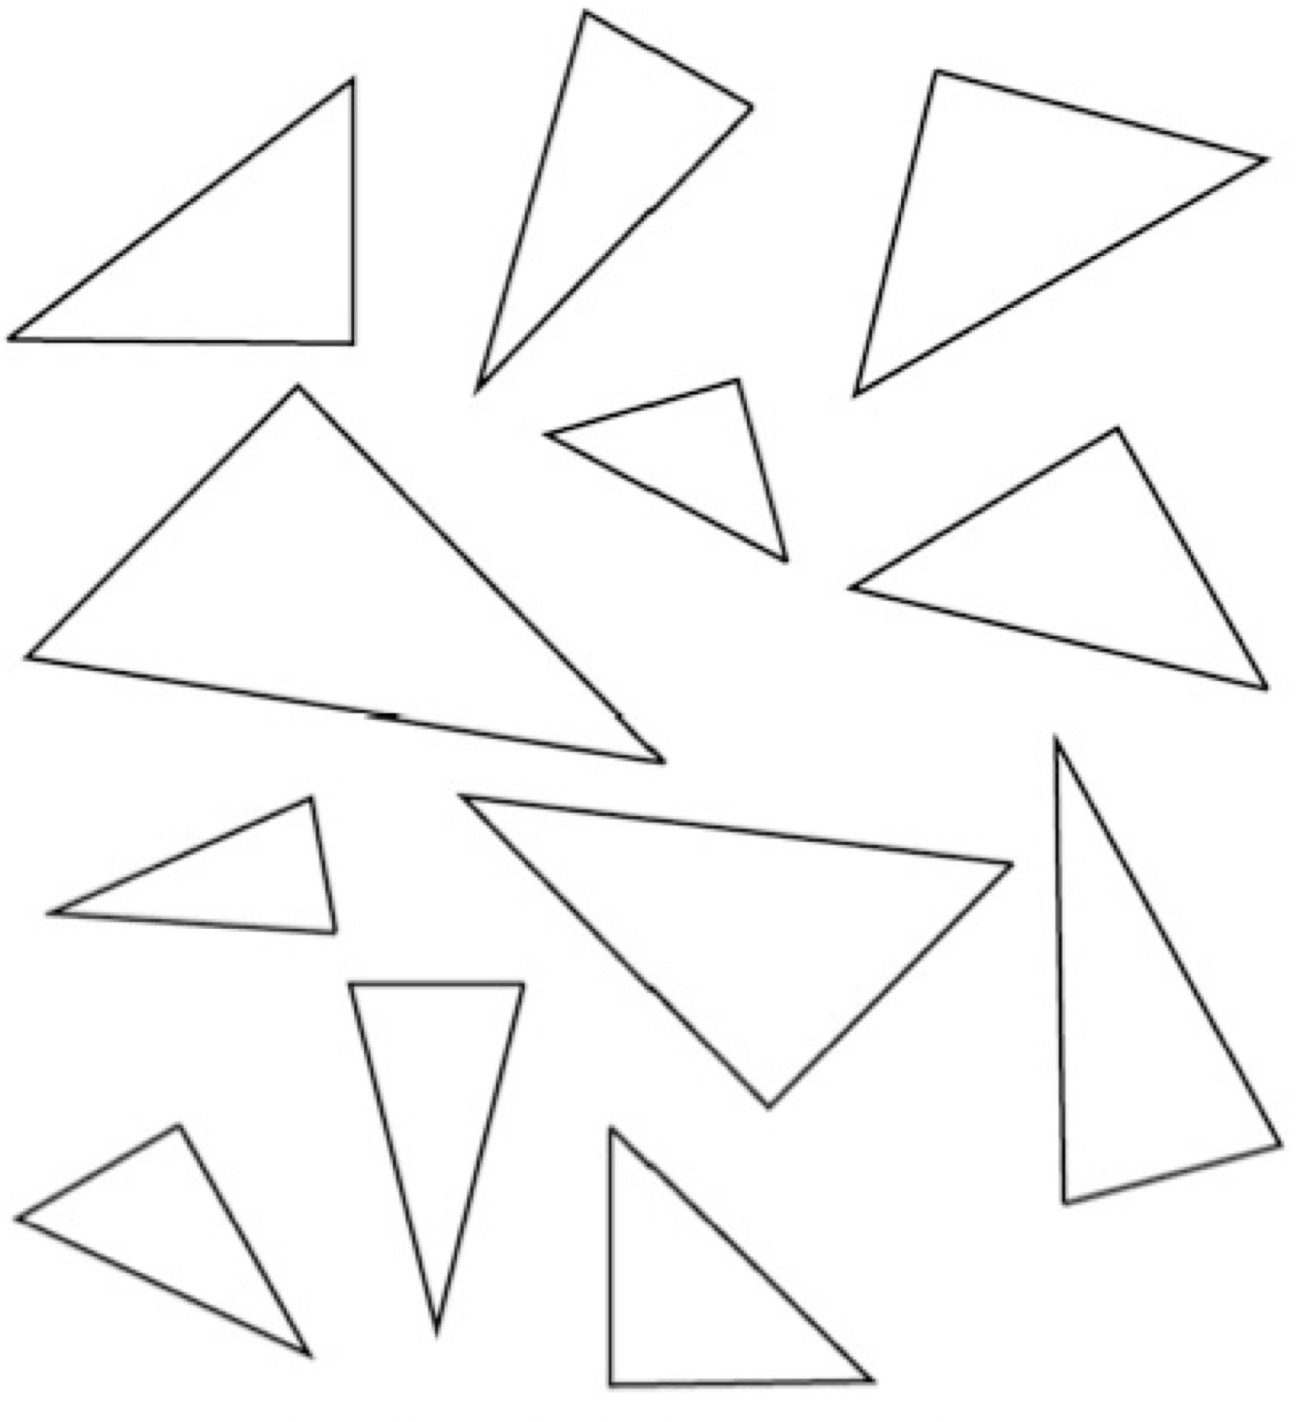

All the triangles in a family are the same shape, but they are not the same size or the same way up.
Can you sort them out?

