Year 10 Common Task: Graphs of Rational Functions

A first lesson

In the first lesson I try and link back to previous work on functions and graphs. The motivation to look at graphing rational functions will come simply from the mathematical extension of previous work and will be introduced by me.

In silence, begin a linear function game, e.g.

3 →5
5 →9
9 →

Hopefully students will spot the rule and pattern fairly quickly, and I or they will introduce algebra to express this, x →

Again, much more quickly than in previous years, sketch these points on a grid (no need for students to copy it) and highlight the gradient and y-intercept and how these link to the rule.

My attention here is not on whether everyone remembers this, or can now use y=mx+c. There will be opportunity to re-visit this idea within the more complex space of rational functions. This beginning is more about reminding students how to generate co-ordinates from rules.

- Up to this point in Maths most of the graphs you have ever looked at are of this form; some number multiplied by x and then another number added or subtracted. One way that mathematics advances is that someone one day decides to see what happens if you apply an idea from one context to a different context. This is what we are going to do today. You have all met the idea of division since you were in Primary school. What probably none of you have done is apply this idea to graphs. In this project we are going to be exploring what kinds of graph we if instead of just looking at y=ax+b, we look at graphs of the form $y=\frac{\text{ax}+b}{\text{cx}+d}$ or even $y=\frac{{\text{ax}}^{2}+\text{bx}+c}{\text{dx}+e}$
[Decision here about whether to introduce a second type at this point – I personally always like to get in as soon as possible the extent of the complexity of the task.]

So, could someone give me an example of a graph of the first type, make up any numbers you like for a, b, c and d.

~ a is 1, b is 2, c is 3 and d is 4

- Okay, so we are going to plot, $y=\frac{x+2}{3x+4}$ , we will work together until everyone can do this and then you will have a go at doing your own ones, with the challenge of being able to predict what they will look like before working out any points. Anyone got any ideas on this one before we begin? [You may not get any response to this, but still worth asking!]

- All we need, in fact, with these graphs, is to get an accurate sketch. We don’t need to plot loads and loads of points, we just need to capture the key features. So, any suggestions about how to begin?

Some key points need to come out of this discussion, for sketching these graphs, which need to be written clearly somewhere for students to refer to when doing their own ones:
- Find what happens when x=0
- Find what happens when y=0
- Find when the denominator=0 (introduce the words ‘vertical asymptote’ to describe this)
- Find what happens for large +ve and –ve values of x (to give the horizontal asymptote – you can also deal with this by dividing top and bottom by x and then considering what will happen as x tends to + or - infinity)
- (Depending on how the discussion goes) Find what happens either side of the vertical asymptote

It will probably take most of a lesson to establish these points and go through them for the one example. It is important students do end up with a sketch in the first lesson, with asymptotes labelled and also points where the graph crosses the axes.

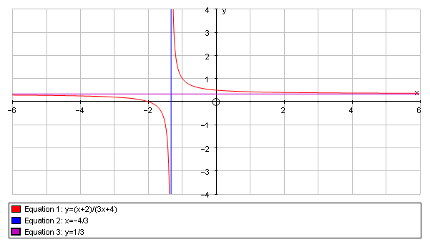

Where this can go

The basic task is for students to try their own rules and try and predict what the graph will look like. Do not be suprised if these take a long time for some students to do! Graphs should be done on paper and pinned up on a wall, with the equation written large. Workings can be done in students’ exercise books.

Students may get conjectures around:
- predicting the horizontal asymptote (e.g., $y=\frac{a}{b}$)
- generalising the equation of the vertical asymptote
- predicting overall shape (i.e., ‘which way around’ it is)
- generalising where the intercepts are

Possibilities

Students can go onto the second type of graph. In general there will no longer be a horizontal asymptote, but an oblique one, that can be a little tricky to find – one method is to re-arrange the top so it factorises with the bottom, e.g., for $y=\frac{x^{2}+5x+7}{x+2}$:

$$\begin{aligned}y=\frac{x^{2}+5x+7}{x+2}⇒y=\frac{x^{2}+2x+(3x+7)}{x+2}⇒y=\frac{x^{2}+2x}{x+2}+\frac{3x+7}{x+2} \\ \\ ⇒y=x+\frac{3x+7}{x+2} \\ \\ \text{As}x→∞, \\ ⇒y→x+3\end{aligned}$$
So the graph tends towards y=x+3
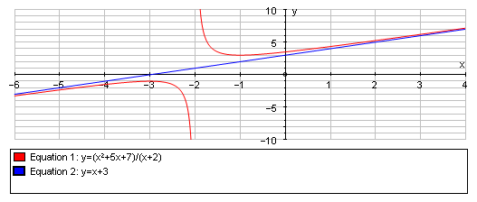

Typical mathematical content

- Reading algebra
- Substituting into formulae, including very large numbers
- Plotting co-ordinates
- Arithmetic with negatives
- Gradients and intercepts of straight line graphs
- Generalising with algebra
- Transforming equations
- Solving linear equations

