Square Ribbons

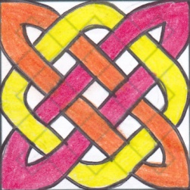
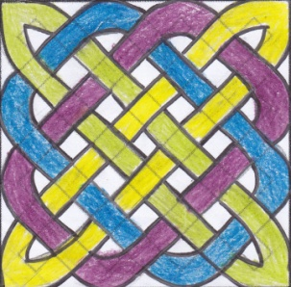
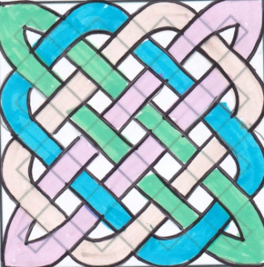
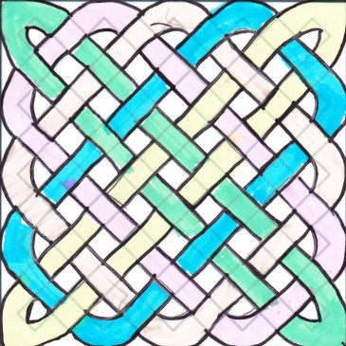

- To work out the total number of overlaps, add the holes between the ribbons and subtract 1.

- The number of ribbons on the top row indicates the amount of ribbons used in a pattern.

Rectangular Ribbons

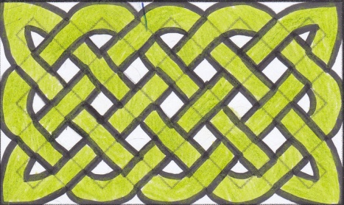
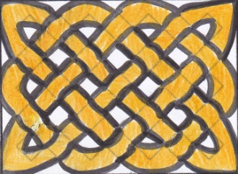

- To work out the total number of overlaps, add the holes between the ribbons and subtract 1.

By: Kenn, Jong Woong, Jayme and Mariana from Garden International School

