Engaging mathematics for all learners

“The new secondary curriculum aims to inspire all young people to become successful learners, confident individuals and responsible citizens. As a result, the mathematics programmes of study have changed significantly.
Every learner is entitled to experience mathematics as worthwhile, enjoyable and challenging, regardless of their prior attainment and background. One way of realising this is to make ‘enrichment and enhancement tasks’ available to all learners.”
Quote taken from the QCA website: http://www.qca.org.uk/qca_22221.aspx


One source of enrichment and enhacement tasks is the NRICH wesite. Teachers’ notes are provided to offer suggestions on how to use the tasks, and curriculum mapping documents are continually updated.

http://nrich.maths.org

Video case studies showing how two schools increased the use of NRICH resources in the teaching of mathematics:

Comberton Village College’s case study – ”Riches for all”

Sharnbrook Upper School’s case study – “A richer mathematical experience”

There are thousands of problems on the NRich website. Here is just one…
(you may recognise this activity from Comberton’s video case study!)

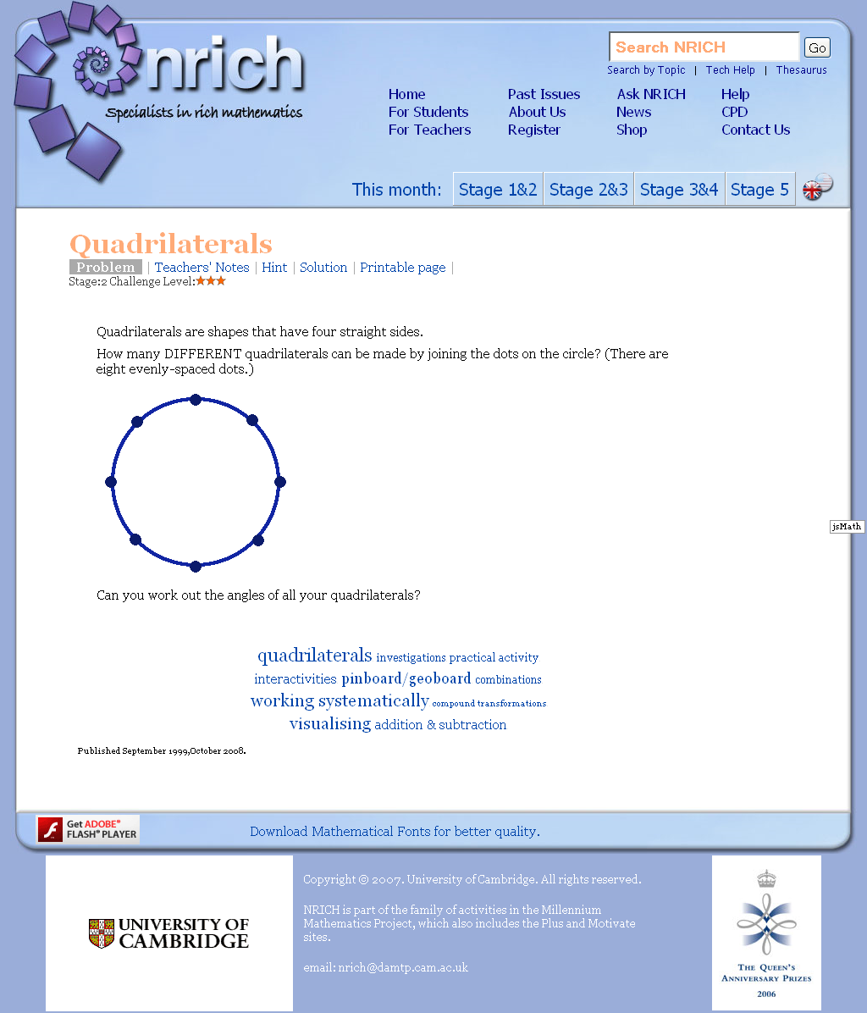
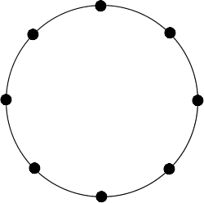

Some ideas on how else you can use this problem:

- Increase or decrease the number of dots to offer extension or support
- Introduce a dot in the centre of the circle; what would happen if one of the vertices (corners) of your quadrilateral was in the centre of the circle?
- A coding activity – how would you describe the quadrilateral so someone else would draw exactly the same one without seeing it?
- Opportunity to use mathematical vocabulary, e.g. parallel lines, isosceles, names of special quadrilaterals etc.
- Discuss rotations and reflections
- Practise measuring angles or use angle properties/facts to derive angles
- Investigate triangles in the circle – with all three vertices on the circumference of the circle or with two vertices on the circumference and one in the centre of the circle
- Provides a really practical introduction to circle theorems (B to A* grade at GCSE)

Be inspired…

NRICH Teacher Inspiration Days - A free professional development programme for mathematics teachers at maintained sector schools/colleges in the UK, delivered as three one-day events over the course of the 2009/10 year. Dates for the programme are 2nd October 2009, 18th March 2010 and 2nd July 2010.
Deadline for Applications: 29th June 2009
http://www.mmp.maths.org/teacher_days

