Some ideas to promote NRICH in your department

Example from Comberton Village College’s scheme of work:

Topic |  |  | Learning Objective | Level | Keywords | NRICH
 |  |  | CAME (Year 8 only) TM17: Sets and Sunsets |  |  | Suggested activities:
 |  | Decimals | Order decimals and use this to compare the size of things in different contexts | 4 | Order  Ascending/Descending  Metric  cm, m, mm, km, etc.  l, ml, cl, etc.  g, kg, mg, tonnes, etc.  Estimate  Measure  Mass / Length / Area / Capacity / Volume / Time | Largest Product
CNum1 | NUMBER SKILLS | Decimals | Use names and abbreviations of metric units of measurement to measure, estimate, calculate and solve problems in everyday contexts ( to include length, area, mass, capacity, volume, time, angle) | 5 |  | Route Product
CNum1 | NUMBER SKILLS | Decimals | Compare metric measurements by converting them into the same units  e.g. Which is larger, 700m or 0.6km? Ext: Which is larger, 60cm² or 0.03m² | 5 |  | Repetitiously
CNum1 | NUMBER SKILLS | Decimals | Multiply and divide decimals by 0.1, 0.01, etc. and have some understanding of why multiplying by 0.1 makes a number bigger | 6
CNum1 | NUMBER SKILLS | Decimals | Multiply a decimal by a decimal,  e.g. If we know 34 x 21 = 714, calculate 3.4 x 2.1; 1.2 x 0.8. NOT harder | 6
CNum1 | NUMBER SKILLS | Negative Numbers | Order negative integers and decimals  e.g. write in ascending order, -0.82, -0.94, -0.12, -1.62 | 5 | Negative  Positive  Add  Subtract  Multiply  Divide | Consecutive Negative Numbers
CNum1 | NUMBER SKILLS | Negative Numbers | Review adding and subtracting positive and negative numbers  e.g. 5 + -3, -2 + -3, 5 - 9, -4 - 9, 5 - -2, -6 - -1, etc. | 5 | Negative  Positive  Add  Subtract  Multiply  Divide | Weights
CNum1 | NUMBER SKILLS | Negative Numbers | Multiplying and dividing with negative numbers  e.g. 5 x -2, -4 x 6, -2 x -4, -1.2 x 0.8, etc. | 5 | Negative  Positive  Add  Subtract  Multiply  Divide | Playing connect 3

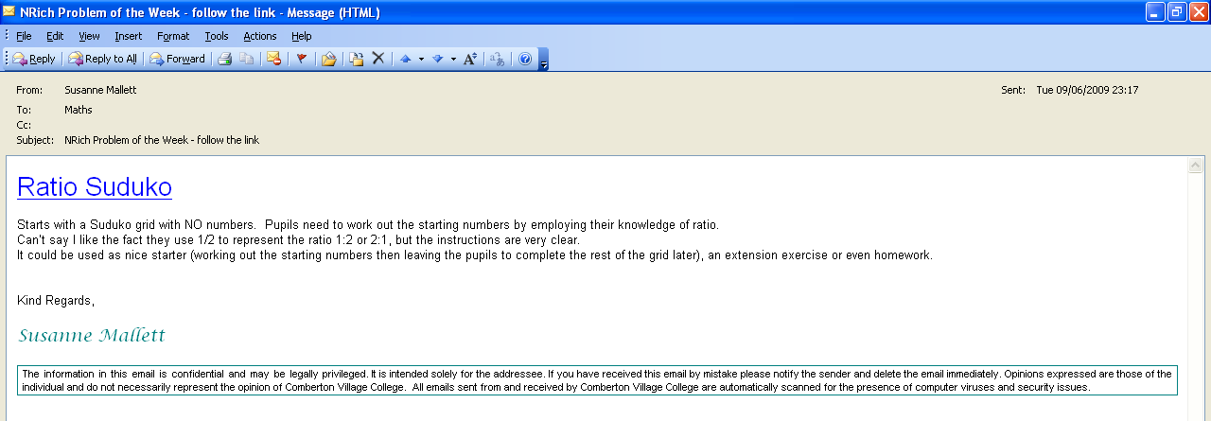

Comberton Village College  Mathematics Dept. Newsletter  11/05/2009 – 15/05/2009  NRICH activities of the week:  These activities combing transformations and straight line graphs…really interesting!  Reflecting Lines  Translating Lines  Surprising Transformations | Comberton Village College  Mathematics Dept. Newsletter  2/3/2009 – 6/3/2009  NRICH  Do you know that there is a weekly UKMT problem on the NRICH website…ideal for starters…here is a link to this week’s problem

