Close to Triangular – Triangles through points
Given three points, it is always possible to draw different triangles with edges passing through those three points - here are some examples of triangles going through the same three points:

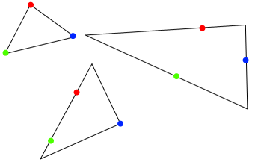
Can you convince yourself that there are always infinitely many such triangles?
Here are some examples of different triangles going through the same set of four points:
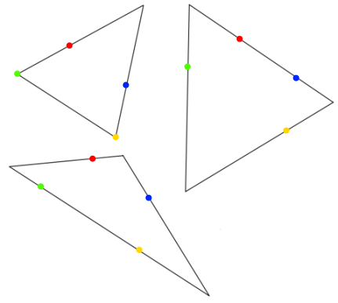
Is it always possible to draw triangles through a set of four points?
Investigate some examples and explain your findings.
What happens when we try to draw triangles through five points?

