Partially Painted Cube

Jo made a cube from some smaller cubes. She painted some of the faces of the large cube, and then took it apart again.
She counted her cubes and noticed that 45 cubes had no paint on them at all.
Can you work out how many small cubes Jo used to make her large cube, and which faces she painted?

Dan made a cube the same size as Jo's large cube, and also painted some of the faces.

How many unpainted cubes might Dan end up with?

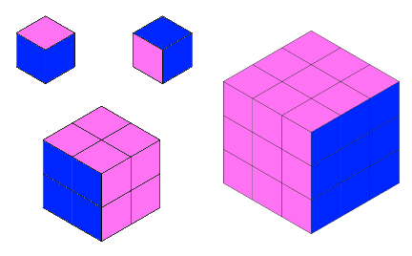

So far, you have only considered one size of cube. Mathematicians often build on starting points like this and ask themselves questions that apply more generally.
What questions do you think might be worth exploring?

Agree within your group a line of enquiry, and decide how you are going to proceed. Record your ideas and findings to share with the rest of the class.

