Growing Rectangles

Imagine a rectangle with an area of 20 cm².
What could its length and width be? List at least five different combinations.
Imagine enlarging each of your rectangles by a scale factor of 2:
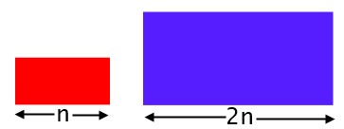
List the dimensions of your enlarged rectangles and work out their areas.
What do you notice?
Try starting with rectangles with a different area and enlarge them by a scale factor of 2.
What happens now?
Can you explain what's going on?

What questions do you think mathematicians might be interested in exploring next?
Choose a line of enquiry to work on in your group.
Record your questions and findings ready to present them to the rest of the class.

