Hand-drawn Fractals

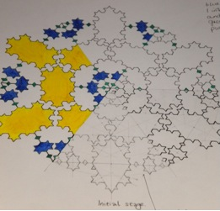

This has been coloured to show the stages of creation.

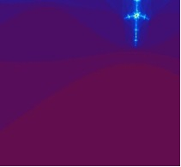

This is a painting of a Mandelbrot enlargement.
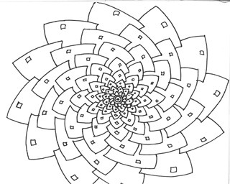

This Fractal is based on the bottom of a pine cone. Strictly speaking, it is inaccurate, as the pine cone spiral has 13 components. This has only 12. However, as an art image, this is better, as it allows for much easier distribution of colours.
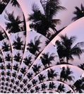This fractal was made using Paint.net and a holiday photograph. The tool required to make such an image is in the Effects tab at the top of the program screen.

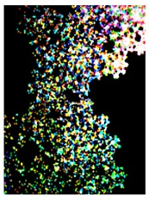
This is an early attempt, using the Render as Fractal facility, followed by Emboss. The enlargement and cropping of the image caused it to lose definition and become a little blurred. However, the effect is almost organic, giving it the appearance of a micro-organism, or mineral structure.

