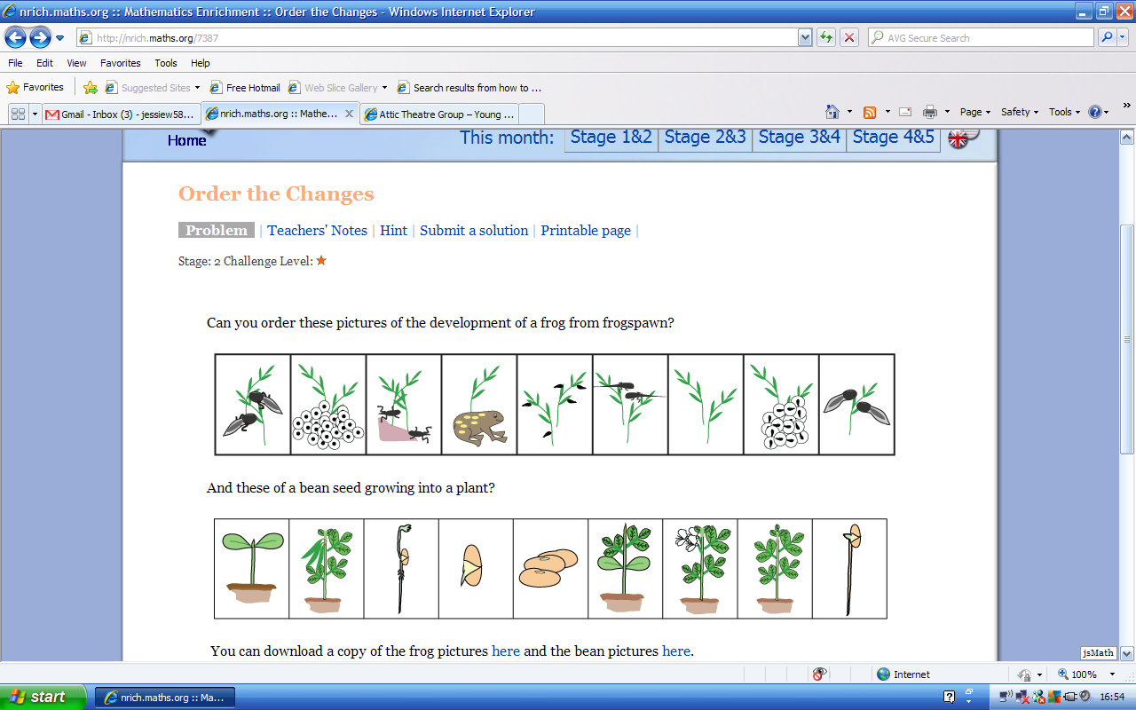
Seeds are planted in the ground. Their journey is just beginning.
The seed starts to split revealing a small root.
A small root buries into the ground. It can now find nutrients in the soil and bring it back to the plant.
The root gets longer and digs down further into the soil for nutrients. A shoot starts to appear at the top.
The shoot starts to grow a couple of small leaves.
Soon more are growing and more are still on the way.
The plant is now completely covered in leaves and will soon be covered in small flowers.
Flowers start to bloom all over the plant making it look pretty and attractive.
The beans start to grow where the flowers used to be. They are now ready to be picked and eaten.

