Mohammed , Nelson, Mel, Netty
E F G I K L M N O Q R U V X Y Z j m ns w
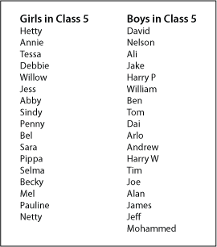
A I I I I I I Q Y
B I I I J I I I I R Z
C K S I I I
D I I I L T I I
E M I I U
F N I I V
G O W I I
H I I I P I I I X

Frequency Table

A 6 I 0 Q 0 Y 0
B 3 J 5 R 0 Z 0
C 0 K 0 S 3
D 3 L 0 T 2
E 0 M 2 U 0
F 0 N 2 V 0
G 0 O 0 W 2
H 3 P 3 X 0

Block graph

6
5 |  |  |  |  |  |  |  |  | 5
4 |  |  |  |  |  |  |  |  | 4
3 | 3 |  | 3 |  |  |  | 3 |  | 3 |  |  |  |  |  | 3 |  |  | 3
2 | 2 |  | 2 |  |  |  | 2 |  | 2 |  |  | 2 | 2 |  | 2 |  |  | 2 | 2 |  |  | 2
1 | 1 |  | 1 |  |  |  | 1 |  | 1 |  |  | 1 | 1 |  | 1 |  |  | 1 | 1 |  |  | 1
A | B | C | D | E | F | G | H | I | J | K | L | M | N | O | P | Q | R | S | T | U | V | W | X | Y | Z

I didn’t know how to draw things on this graph so I substituted the drawings with numbers.
Nellie, Mel, Nelson and Mohammed are absent that day

Class 5 Boys and Girls Names

I left out the x and the z because other wise the graph would get a little to long and skinny not that it isn’t now.
And the letters are J M N P S.

